**APPLE I-STORE**

**USER**

**INSTRUCTIONS**



**TABLE OF CONTENTS**

|  |  |
| --- | --- |
|  | **Page no** |
| 1. **Introduction**     1. **Purpose of the manual**   **1.2 Target Audience**  **1.3 System Requirements**   * 1. **Getting app from the Apple store** |  |
| **2.Getting Started**  **2.1 Installation**  **2.2 System requirements**  **2.3Initial Setup**  **2.4 Logging In** |  |
| **3.Overview of the Interface** |  |
| **4.Troubleshooting**  **4.1 Common Issues**  **4.2 Performance Issues**  **4.3 FAQs** |  |
| **5.Technical Support**  **5.1Contact Information**  **5.2 Business Hours** |  |
| **6.Legal Information**  **6.1 License Agreement**  **6.2 Copyright Information**  **6.3 Trademarks** |  |
| **7.Glossary** |  |

1. **Introduction**
   1. **Purpose of the manual**

* Welcome to APPLE I-STORE ! This user manual has been crafted to help you navigate and make the most of our desktop application, available on the Apple Store. Whether you're a new user looking to get started or an experienced user seeking advanced features, this manual provides comprehensive guidance.
  1. **Target Audience**
* This manual is designed for users of all levels of expertise, from beginners to advanced users. It aims to provide clear instructions and insights into the functionalities of APPLE I-STORE.If you have just downloaded the app or are considering doing so, you'll find step-by-step guidance on installation, setup, and usage.
  1. **System Requirements**
* Before diving into the application, please ensure that your system meets the necessary requirements for optimal performance. Check the Apple Store listing for the latest information on system compatibility and any specific hardware or software prerequisites.
  1. **Getting App from the Apple Store**
* To obtain APPLE I-STORE visit the Apple Store on your desktop and search for our application. Follow the download and installation instructions provided by the Apple Store. If you encounter any issues during this process, refer to Section 2.1 (Installation) for troubleshooting tips.

**2.Getting Started**

**2.1 Installation**

1. Open the Apple Store on your desktop.
2. In the search bar, enter "APPLE I-STORE”.
3. Locate the app in the search results and click on it.
4. Click the "Download" or "Get" button to initiate the installation process.
5. Follow the on-screen instructions to complete the installation.

**2.2 System Requirements**

* Before installation, ensure that your system meets the following requirements:

1. Operating System(ios,windows,linux)
2. Ram space(minimum 4GB)
3. Make sure your O/S is running with the latest version.

**2.3 Initial Setup**

* Once APPLE I-STORE is installed, follow these steps to set up the application:

1. Launch the Application:

* Double-click the APPLE I-STORE icon on your desktop or find it in your Applications folder.

1. Login:

* If the application requires a login, enter your credentials in the provided fields. If you don't have an account, follow the on-screen prompts to create one

1. Welcome Screen:

* Familiarize yourself with the welcome screen, which may include introductory information or tips.

1. Explore the Interface:

* Take a moment to explore the main menu, toolbar, and any initial setup prompts.

**2.4 Logging In**

* Follow these steps to log in:

1. Open APPLE I-STORE.
2. Click on the "Login" button.
3. Enter your username and password in the designated fields.
4. Click "Submit" or "Login."

**3.Overview of the Interface**

**Step 1:** Enter your username and password and click the login button as shown below.If you need to make the password visible you can click the visibility icon beside the password field.

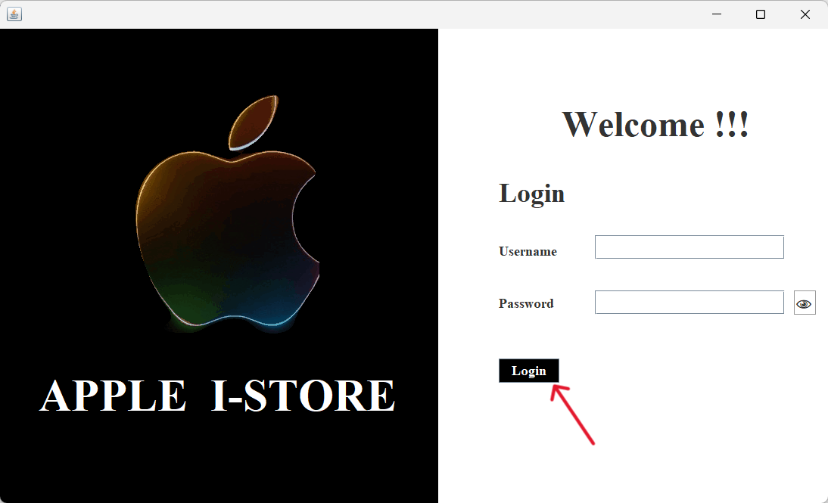

**Step 2:** After the login process is successful it will direct you to your dashboard as shown below.From here you can select any of the menus shown ,based on your requirements and fulfill them.

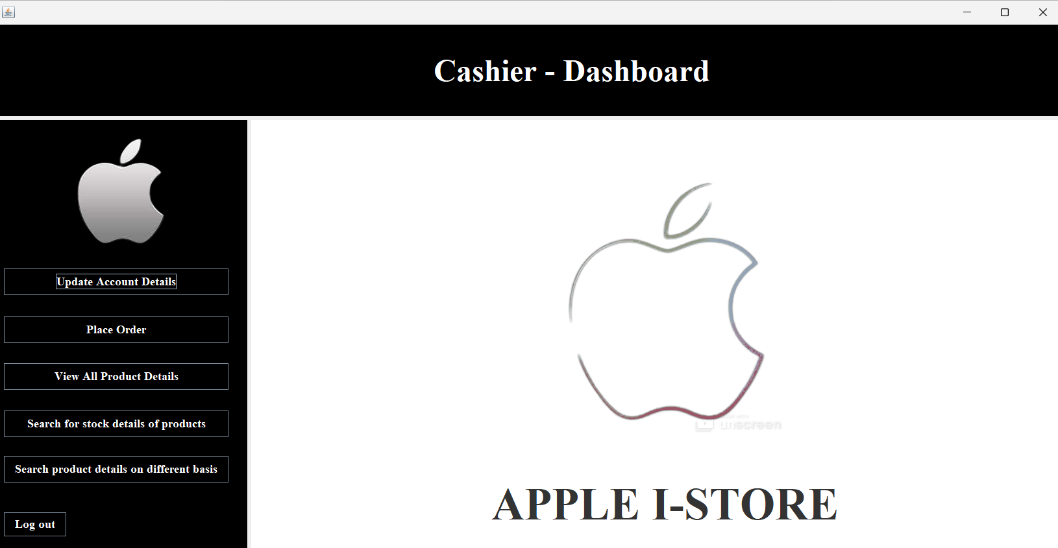

**Step 3:** when you select the "update account details" menu it will direct you to another page where it allows you to update your username ,password.

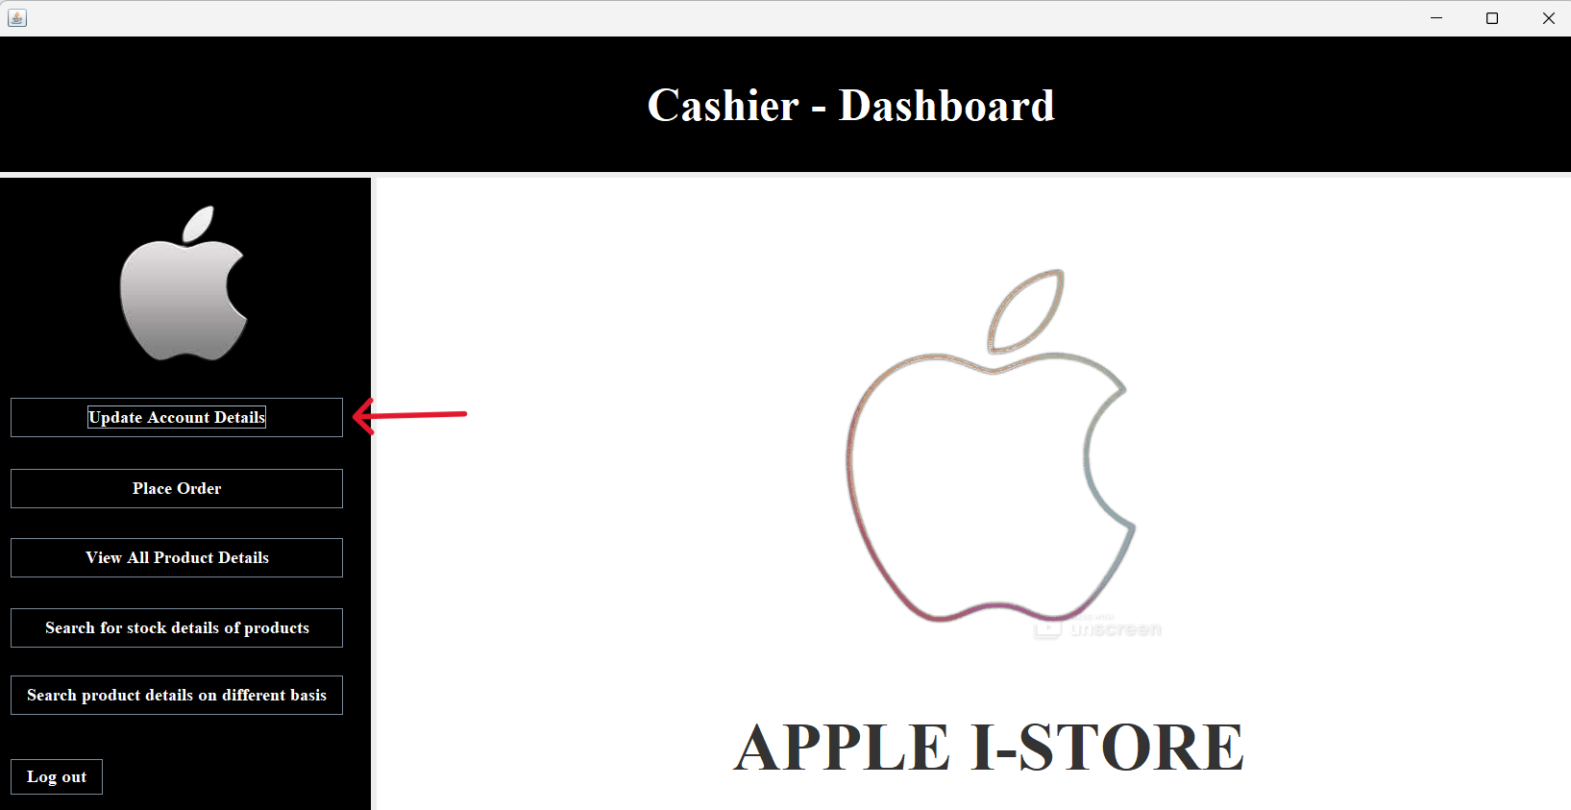

The below is the page where you will be directed to when you click the update "account details menu". When you click the update button as shown below your account details will be modifed to the latest.

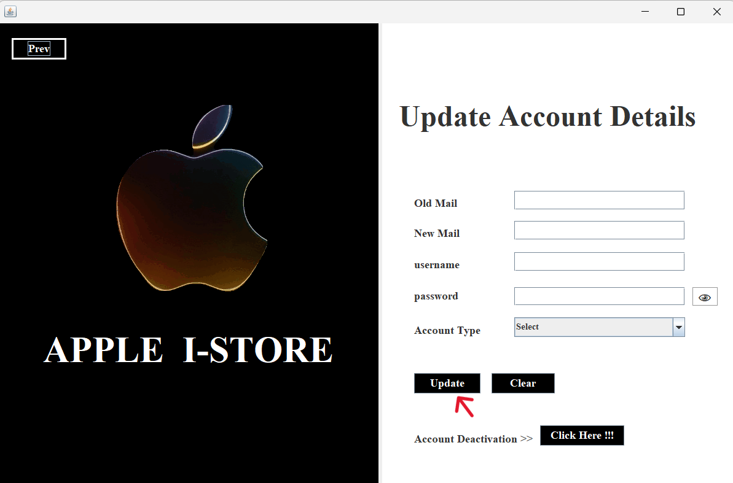

If you need to deactivate your account you can click the "Click here!!!" button as shown below.It will help you to deactivate your account.

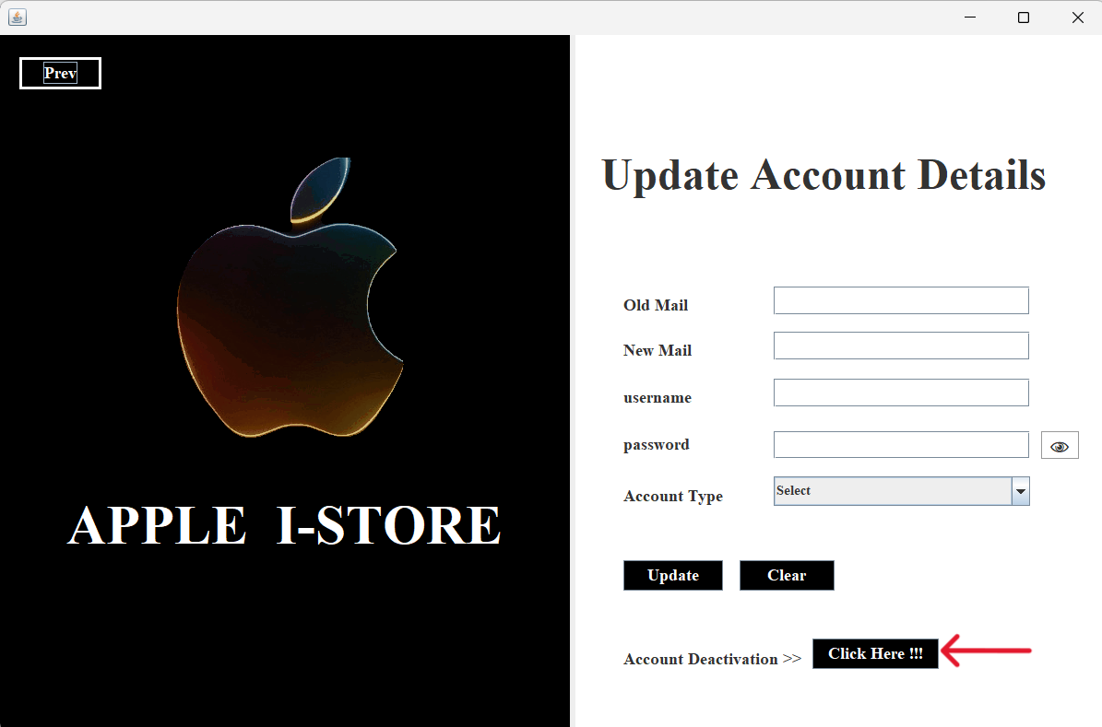

**Step 4:** If you have select the "Place Order" Menu the it will direct you to the place order page where you can make your orders.

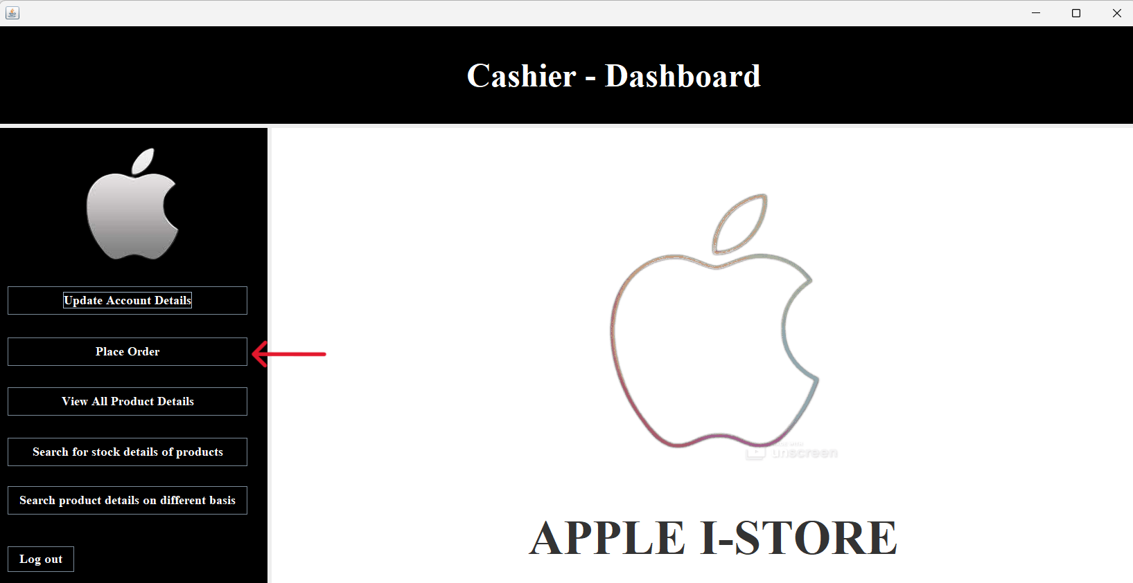

As mentioned above you can order products by filling the product details in the relevant column and click "order" button as shown below.

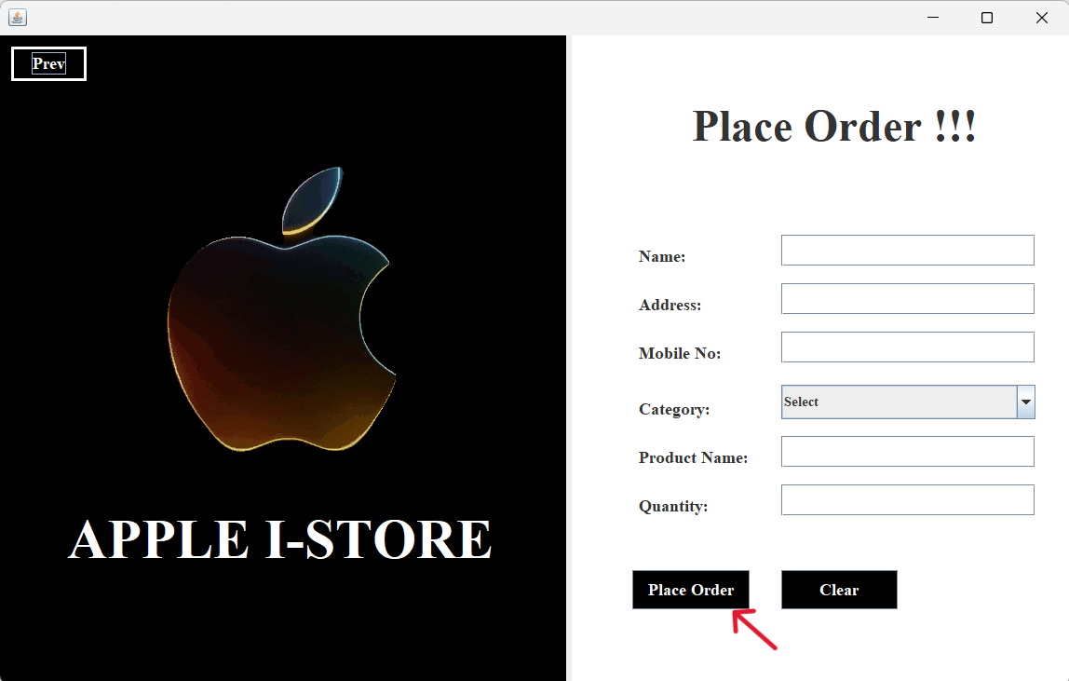

**Step 5:** And then by clicking the "view all product details" button the user is allowed to view all the product details available in our company.

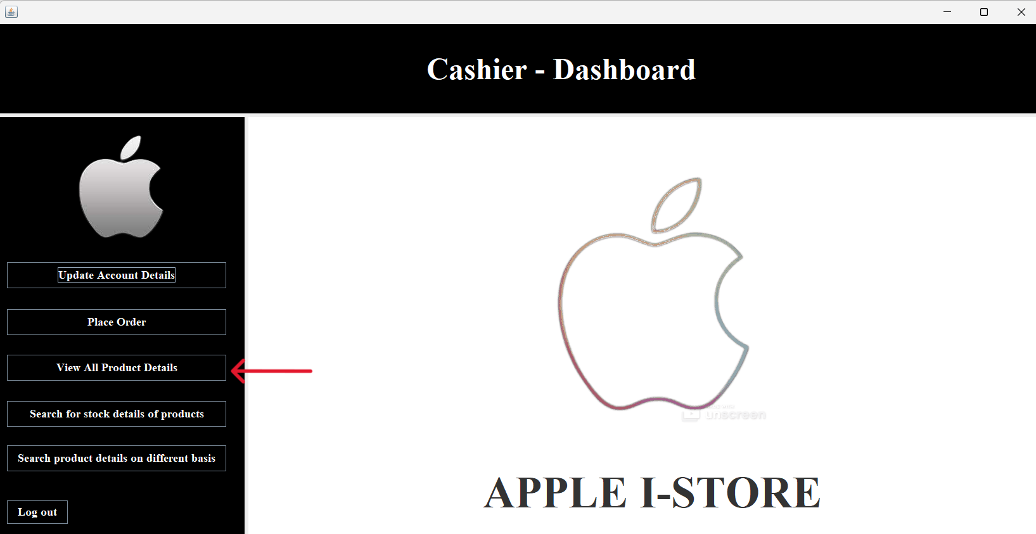

After the "view all product details"button is clicked then it will direct you to the another page as shown below.here you will able to see all product details available in our company.

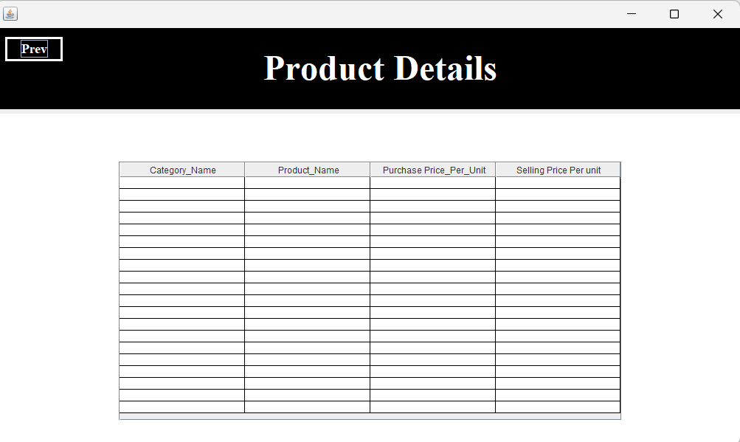

**Step 6:** You can search for the stock details of products by clicking “search for stock details of products” button as shown in the below image.

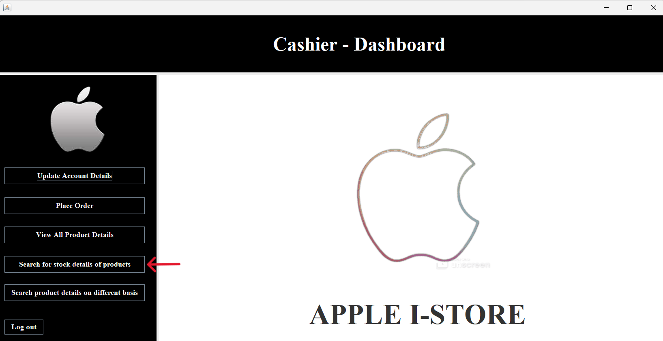

By clicking the above option (“search for stock details of products” button) the application will direct you to another page where you will be able to see the stock details of the products.

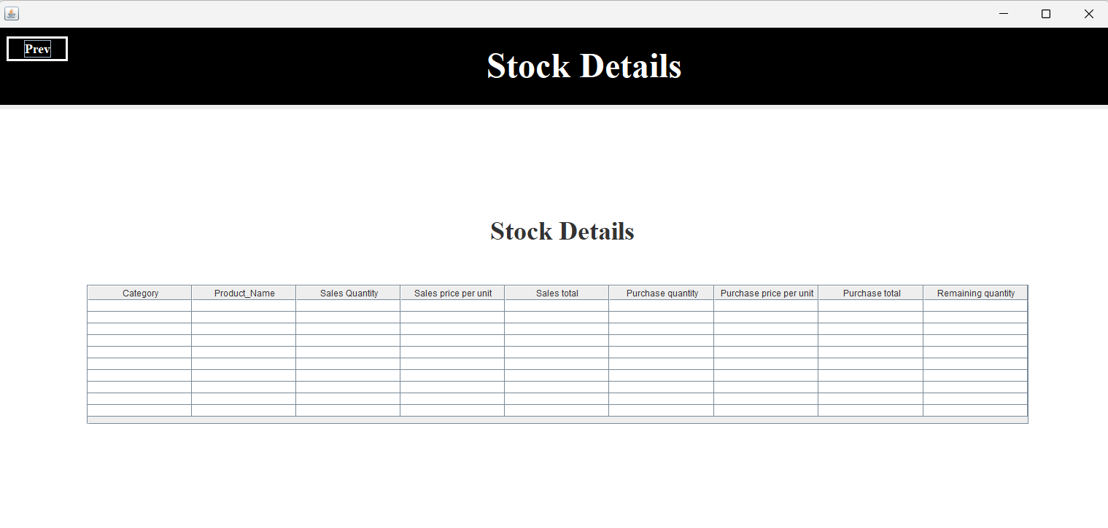

**Step 7:** Inorder to find the product details based on category, name and price ,you can click the last option provided (search for product details on different basis) as shown below.

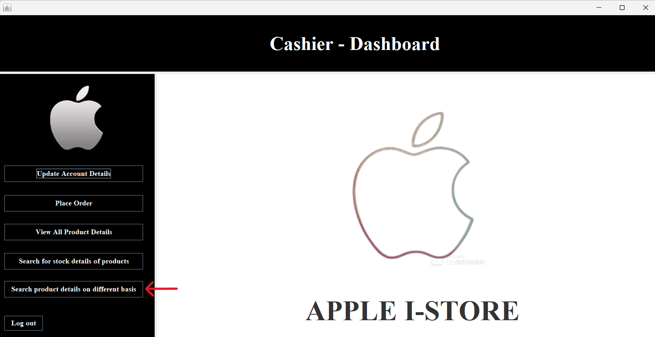

When you click the last option in the dashboard(search product details based on category name and price ),It will direct you to an Interface like below where you will be able to search product based on different basis.

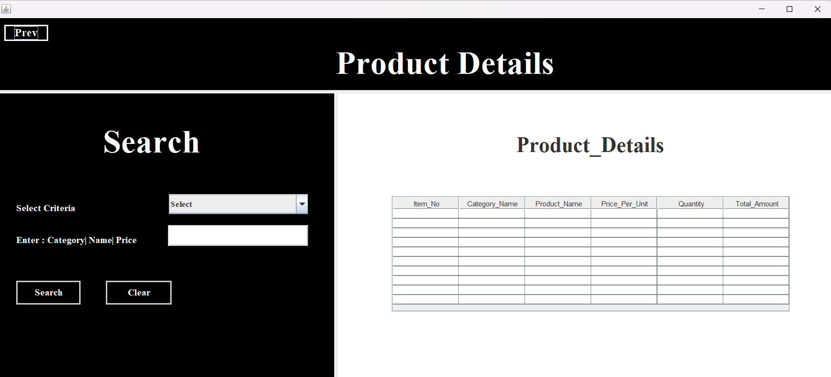

**Step 8:** If you need to logout from your account then you should click the logout button provided in the bottom of the menu as shown below.

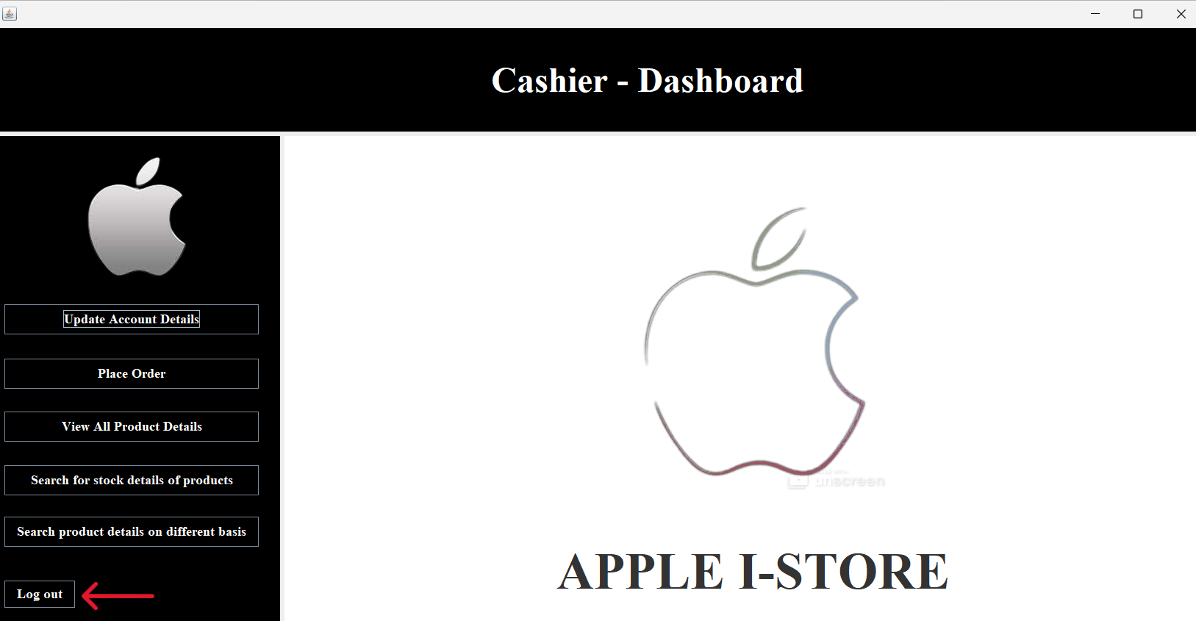

**Note :** you can navigate from the current page to the previous page using the “Prev” button provide at the top-left corner of each pages. One such image is shown below.

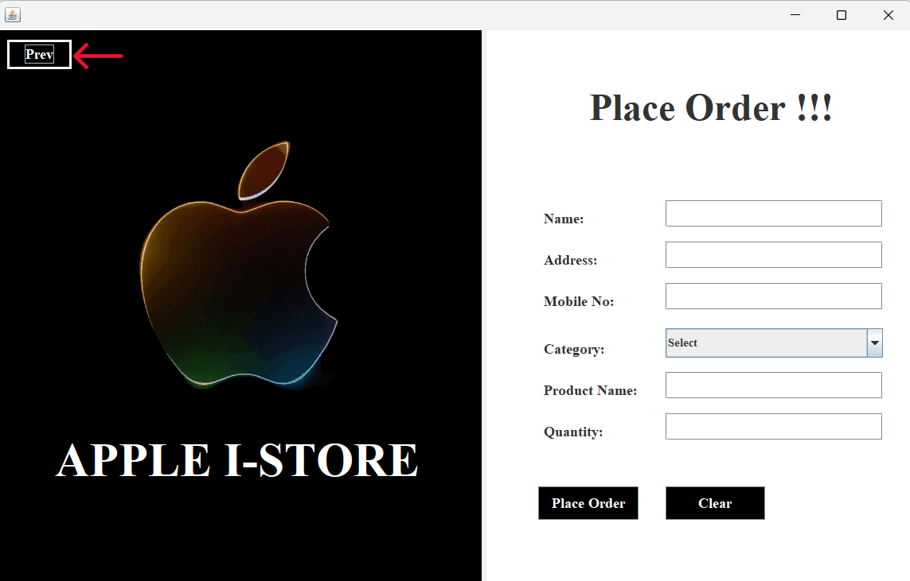

**4.Troubleshooting**

**4.1 Common Issues**

* Application Won't Launch:

1. Check System Requirements:

* Ensure your system meets the minimum requirements specified in Section 2.1.

1. Reinstall the Application:

* Uninstall APPLE I-STORE and reinstall it from the Apple Store.

**4.2 Performance Issues**

1. Check System Resources:

* Close unnecessary applications to free up system resources.

2. Update Graphics Drivers:

* Ensure your graphics drivers are up to date.

**4.4 FAQs**

Q1) How do I update APPLE I-STORE ?

1. Go to the Apple Store.
2. Locate APPLE I-STORE.
3. If an update is available, click "Update."

Q2) What should I do if the application freezes?

1. Close the application and restart it.
2. Check if your system meets the minimum requirements.

Q3) How do I contact support?

1. Refer to Section 5.1 for support contact information.

**5. Technical Support**

**5.1 Contact Information**

* If you require further assistance, you can contact our support team through the following channels:

1. Phone Support:

* Call our support hotline at “081-2222111”during our business hours.

2. Email Support:

* Send an email to “applestore99@gmail.com”. Our support team will respond to your inquiry as soon as possible.

3. Online Support Portal:

* Visit our online support portal at "www.Applestore.com" to submit a support ticket or access additional resources.

**5.2 Business Hours**

* Monday to Friday: 8:00 AM - 5:00 PM
* Weekends: 8:00 AM - 7:00PM
* Please note that response times may vary based on the volume of support inquiries. For urgent matters or critical issues, we recommend contacting us by phone for immediate assistance.

**6. Legal Information**

**6.1 License Agreement**

* By using APPLE I-STORE, you agree to be bound by the terms and conditions outlined in the license agreement. It is important to carefully read and understand this agreement, as it governs your use of the application.

**6.2 Copyright Information**

* APPLE I-STORE is protected by copyright laws and international treaties. All rights reserved.
* Copyright Notice:
* © 2007 APPLE I-STORE. All rights reserved.
* APPLE I-STORE and its logo are trademarks or registered trademarks of APPLE I-STORE.
* Any unauthorized use, reproduction, or distribution of APPLE I-STORE may result in legal action.

**6.3 Trademarks**

* All product names, logos, and brands mentioned in this manual are the property of their respective owners. Mention of third-party products, services, or trademarks is for informational purposes only and does not imply endorsement or affiliation.

**7. Glossary**

**A**

**Interface**

* The place at which independent and often unrelated systems meet and act on or communicate with each other.

**B**

**Troubleshooting**

* Troubleshooting is a systematic approach to solving a problem. The goal of troubleshooting is to determine why something does not work as expected and explain how to resolve the problem.

**C**

**Compatibility**

* A state in which two things are able to exist or occur together without problems or conflict.

**D**

**Prerequisites**

* Something required beforehand or necessary as preparation for something else.